Praveen Kumar Yadav

(MTech VLSI Sem 1, EE22M308)

Lab no. : 6

Used version: Matlab 2022

1. State the Fick's laws of diffusion and the continuity equation.

Ans:

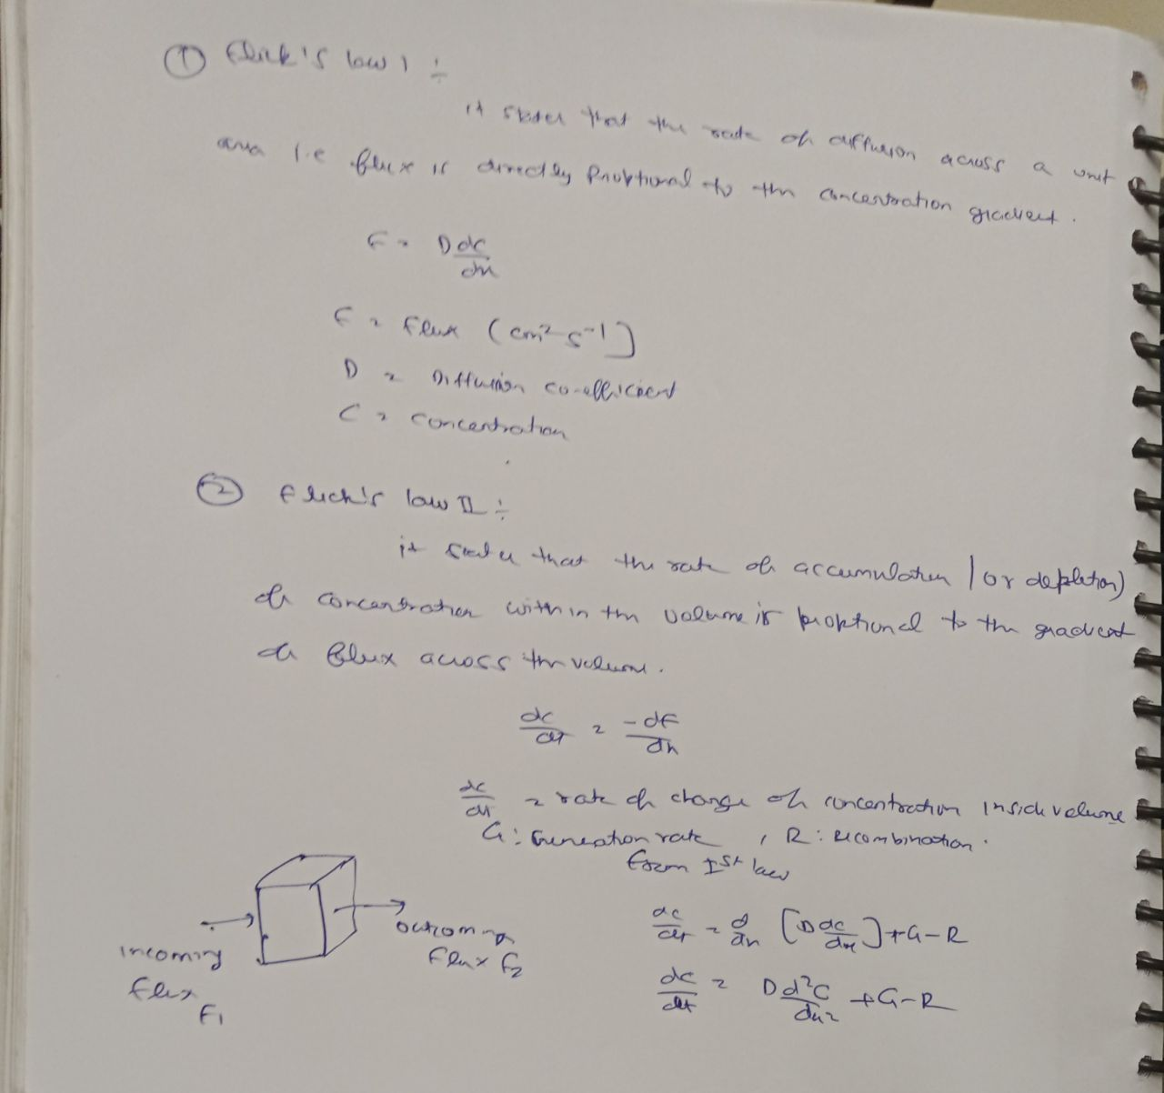

2) For each of the cases listed below, provide the analytical solutions, and compare them

with numerical solutions. Assume steady state and D=30 cm2

/s

(a) Consider diffusive transport of particles between two points A & B separated by

100 μm. The concentration of particles at A is 1012 cm-3 & at B is 0 cm-3. Assume τ=∞.

Find the concentration profile for particles from A to B. What is the particle flux from

A to B?

Ans:

Concentration: Numerical method

clc;

N=100;

Ca=-10^(12);

Cb=0;

C=zeros(1,N);

C(1)=Ca;

C1=C';

for i=1:N-1

M(i,i)=-2;

end

for i=1:N-1

M(i,i+1)=1;

end

for i=1:N-1

M(i+1,i)=1;

end

Cf=inv(M)\*C1;

i=1:100;

plot(i,Cf)

grid on;

xlabel('Distance (µm)')

ylabel('Concentration (cm^-^3)')

title('Concentration profile in Numerical method')

A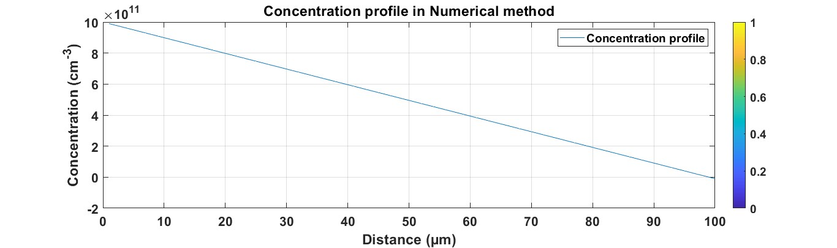

Analytical:

clc;

x=1:100;

c=(-(10^14)\*x)+(10^12);

plot(x,c);

grid on;

xlabel('distance (µm)')

ylabel('Concentration (cm^-^3)')

title('Concentration profile in Analytical method')

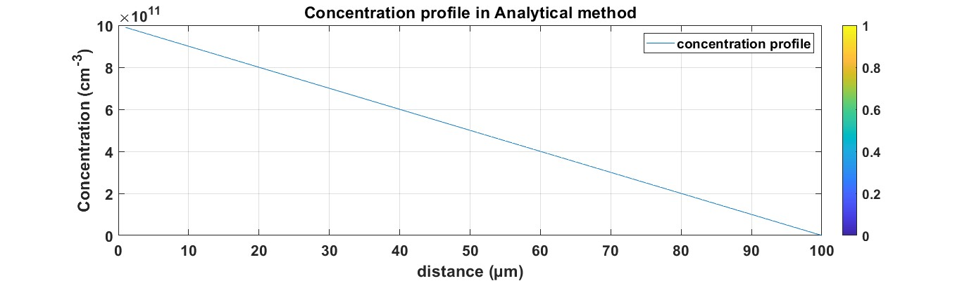

Comparision:

clc;

q=1.6\*(10)^(-19);

a=100\*10^(-4);

h=a/100;

N=100;

Ca=-10^(12);

Cb=0;

C=zeros(1,N);

C(1)=Ca;

C1=C';

D=30;

for i=1:N-1

M(i,i)=-2;

end

for i=1:N-1

M(i,i+1)=1;

end

for i=1:N-1

M(i+1,i)=1;

end

Cf=inv(M)\*C1;

i=1:100;

z=i\*10^-4;

grid on;

xlabel('distance (µcm)')

ylabel('Concentration (cm^-^3)')

title('Concentration profile in Numerical method')

x=1:100;

z=x\*10^-4;

c=(-(10^14)\*z)+(10^12);

plot(z,Cf,z,c);

grid on;

xlabel('distance (µm)')

ylabel('Concentration (cm^-^3)')

title('Concentration profile in comparision between analytical and numerical method')

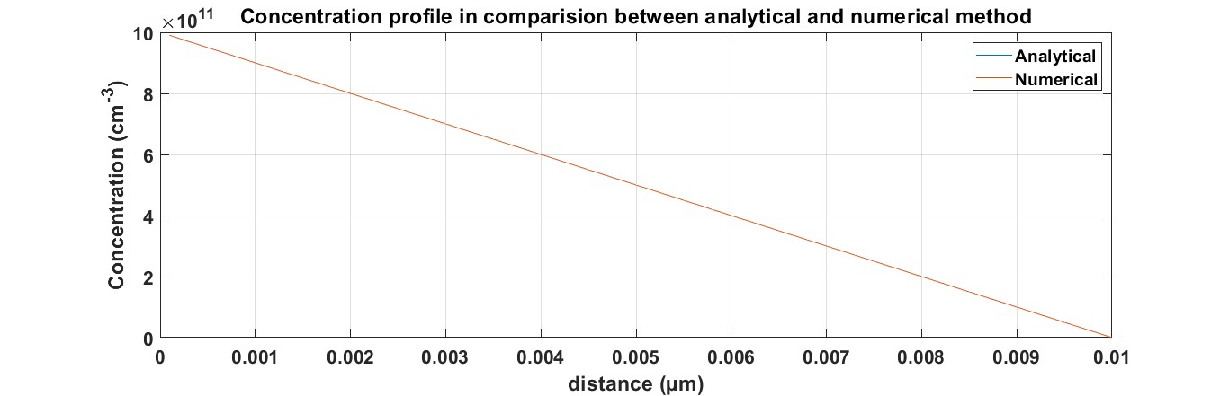

(b) Solve (a) with τ=10-7 s and other conditions remaining the same.

ANS:

ANALYTICAL:

clc

N=1000;

h=(100\*(10^-4))/N;

D=30;

tau=10^-7;

j=(D\*tau)^-0.5;

A=-10^7;

B=10^12;

i=1:100;

y=i\*(10^-4);

c=(A\*exp(j\*y))+(B\*exp(-j\*y));

plot(i,c)

grid on

xlabel('Distance (m)')

ylabel('Concentration (cm^-^3)')

title('Concentration profile in Analytical method')

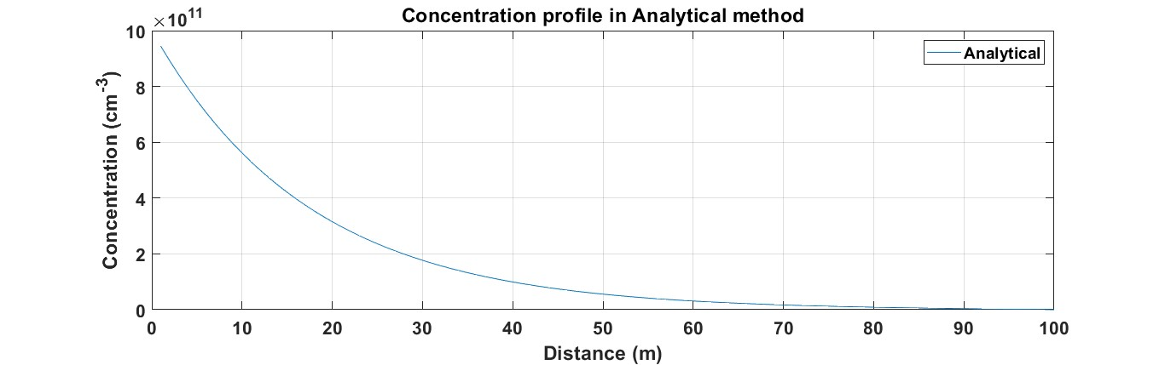

Numerical:

clc;

a=100\*10^(-4);

h=a/100;

N=100;

Ca=-10^(12);

Cb=0;

C=zeros(1,N);

C(1)=Ca;

C1=C';

Tau=10^(-7);

D=30;

for i=1:N-1

M(i,i)=-(2+(((h)^2)/(D\*Tau)));

end

for i=1:N-1

M(i,i+1)=1;

end

for i=1:N-1

M(i+1,i)=1;

end

Cf=inv(M)\*C1;

i=1:100;

plot(i,Cf);

grid on;

xlabel('Distance (µm)')

ylabel('Concentration (cm^-^3)')

title('Concentration profile in Numerical method')

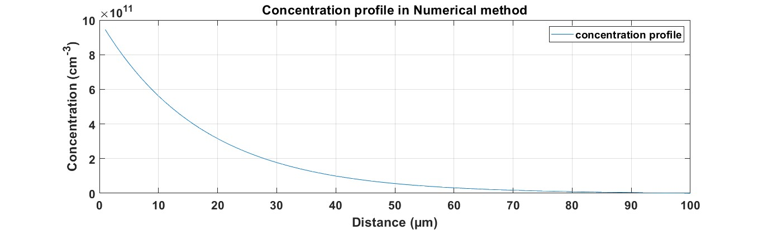

Comparision:

clc

N=100;

h=(100\*(10^-4))/N;

D=30;

tau=10^-7;

j=(D\*tau)^-0.5;

A=-10^7;

B=10^12;

i=1:100;

y=i\*(10^-4);

c=(A\*exp(j\*y))+(B\*exp(-j\*y));

Ca=-10^(12);

Cb=0;

C=zeros(1,N);

C(1)=Ca;

C1=C';

for i=1:N-1

M(i,i)=-(2+(((h)^2)/(D\*tau)));

end

for i=1:N-1

M(i,i+1)=1;

end

for i=1:N-1

M(i+1,i)=1;

end

Cf=inv(M)\*C1;

i=1:100;

plot(i,Cf,i,c);

grid on;

xlabel('distance (µm)')

ylabel('Concentration (cm^-^3)')

title('Concentration profile in comparision between analytical and numerical method')

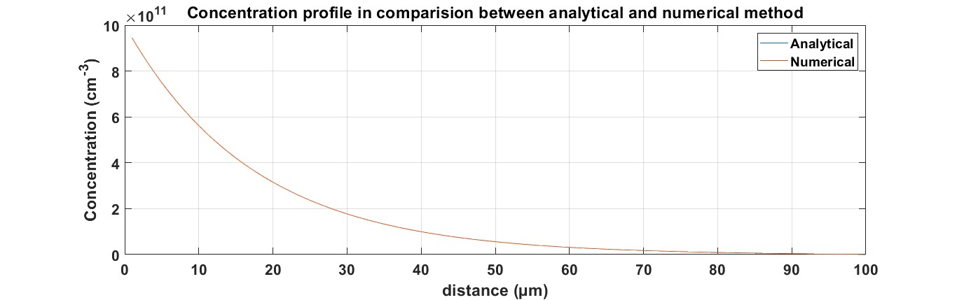

(c) For the configuration in part (a), assume that the boundary condition at B is such

that the particle flux F there is equal to kC, where k=103

cm/s and C is the

concentration there. Assume τ=∞. Find the concentration profile for particles from A

to B.

ans

analytical

clc;

x=1:100;

c=(-(10^14)\*x)+(10^12);

plot(x,c);

grid on;

xlabel('distance (µm)')

ylabel('Concentration (cm^-^3)')

title('Concentration profile in Analytical method')

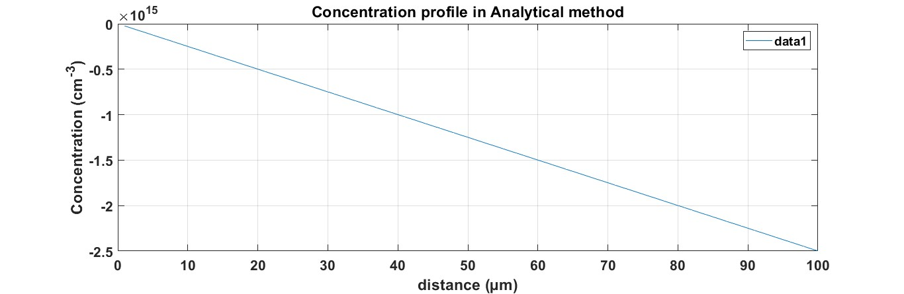

Numerical:

clear all;

clc;

a=100\*10^(-4);

h=a/100;

N=100;

Ca=-10^(12);

Cb=0;

C=zeros(1,N);

C(1)=Ca;

C1=C';

D=30;

for i=1:N-1

M(i,i)=-2;

end

for i=1:N-1

M(i,i+1)=1;

end

for i=1:N-1

M(i+1,i)=1;

end

M(N,N-1)=(-(D/h)+(10^3));

M(N,N)=(-(D/h));

Cf=inv(M)\*C1;

plot(Cf)

grid on;

xlabel('Distance (µm)')

ylabel('Concentration (cm^-^3)')

title('Concentration profile in Numerical method')

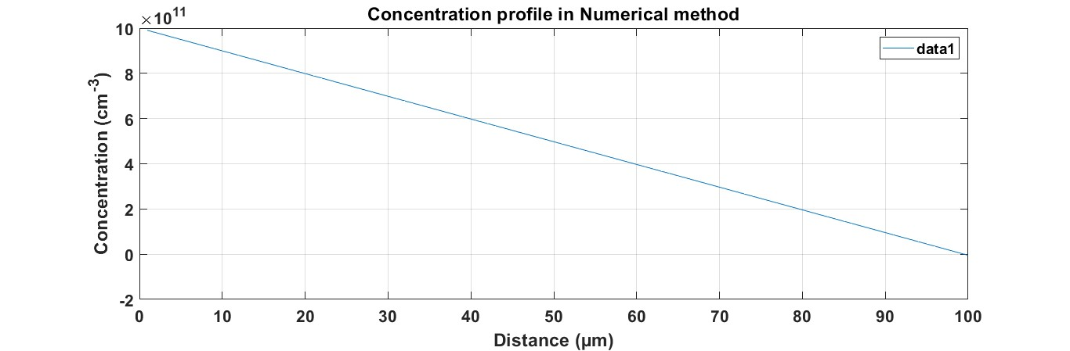

COMPARISION:

clear all;

clc;

a=100\*10^(-4);

h=a/100;

N=100;

Ca=-10^(12);

Cb=0;

C=zeros(1,N);

C(1)=Ca;

C1=C';

y=[];

D=30;

for x=1:100

c=(-(0.25\*(10^14)\*x)+(10^12));

y=[y c];

end

x=1:100;

for i=1:N-1

M(i,i)=-2;

end

for i=1:N-1

M(i,i+1)=1;

end

for i=1:N-1

M(i+1,i)=1;

end

M(N,N-1)=(-(D/h)+(10^3));

M(N,N)=(-(D/h));

Cf=inv(M)\*C1;

plot(x,y,i,Cf)

grid on;

xlabel('distance (µm)')

ylabel('Concentration (cm^-^3)')

title('Concentration profile in comparision between analytical and numerical method')

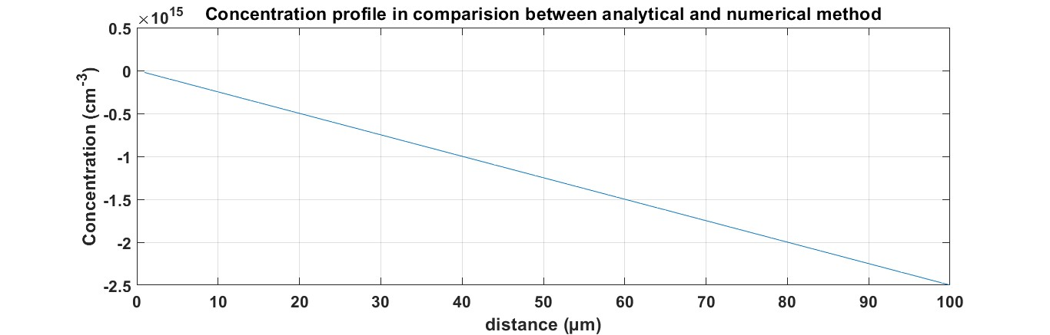

(d) Solve (c) with τ=10-7 s and other conditions remaining the same.

ANS

NUMERICAL

clear all;

clc;

a=100\*10^(-4);

h=a/100;

N=100;

Ca=-10^(12);

Cb=0;

C=zeros(1,N);

C(1)=Ca;

C1=C';

D=30;

Tau=(10^(-7));

for i=1:N-1

M(i,i)=-(2+((h^2)/(D\*Tau)));

end

for i=1:N-1

M(i,i+1)=1;

end

for i=1:N-1

M(i+1,i)=1;

end

M(100,99)=((10^3));

M(100,100)=(-2\*(10^3)-(h^2)/(D/Tau));

Cf=inv(M)\*C1;

plot(Cf)

grid on;

xlabel('Distance (µm)')

ylabel('Concentration (cm^-^3)')

title('Concentration profile in Numerical method')

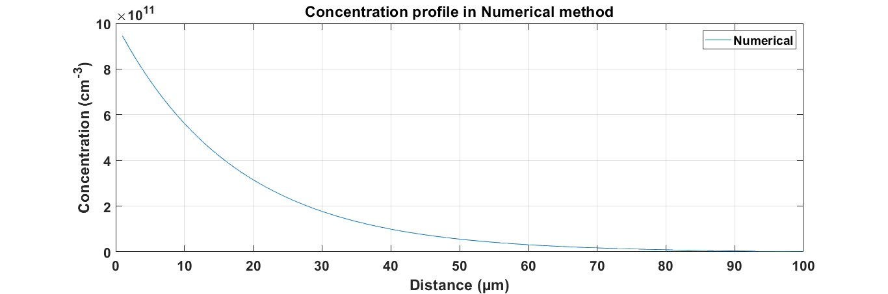

Analytical

clc

N=1000;

h=(100\*(10^-4))/N;

D=30;

tau=10^-7;

j=(D\*tau)^-0.5;

A=-19.65\*(10^9);

B=.981\*(10^12);

i=1:100;

y=i\*(10^-4);

c=(A\*exp(j\*y))+(B\*exp(-j\*y));

plot(i,c)

grid on

xlabel('Distance (m)')

ylabel('Concentration (cm^-^3)')

title('Concentration profile in Analytical method')

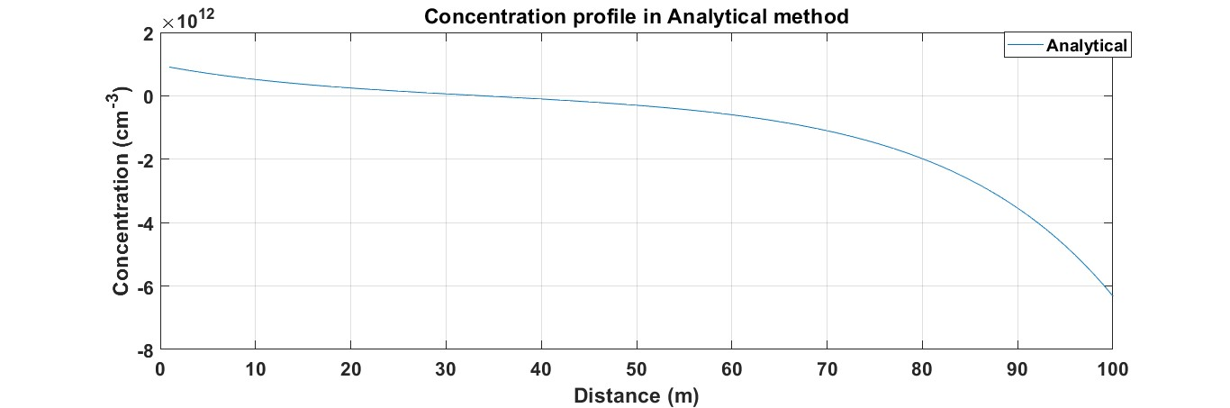

Comparision:

clear all;

clc;

a=100\*10^(-4);

h=a/100;

N=100;

Ca=-10^(12);

Cb=0;

C=zeros(1,N);

C(1)=Ca;

C1=C';

D=30;

Tau=(10^(-7));

for i=1:N-1

M(i,i)=-(2+((h^2)/(D\*Tau)));

end

for i=1:N-1

M(i,i+1)=1;

end

for i=1:N-1

M(i+1,i)=1;

end

M(100,99)=((10^3));

M(100,100)=(-2\*(10^3)-(h^2)/(D/Tau));

Cf=inv(M)\*C1;

N=1000;

h=(100\*(10^-4))/N;

D=30;

tau=10^-7;

j=(D\*tau)^-0.5;

A=-19.65\*(10^9);

B=.981\*(10^12);

i=1:100;

y=i\*(10^-4);

c=(A\*exp(j\*y))+(B\*exp(-j\*y));

plot(i,c,i,Cf)

grid on;

xlabel('distance (µm)')

ylabel('Concentration (cm^-^3)')

title('Concentration profile in comparision between analytical and numerical method')

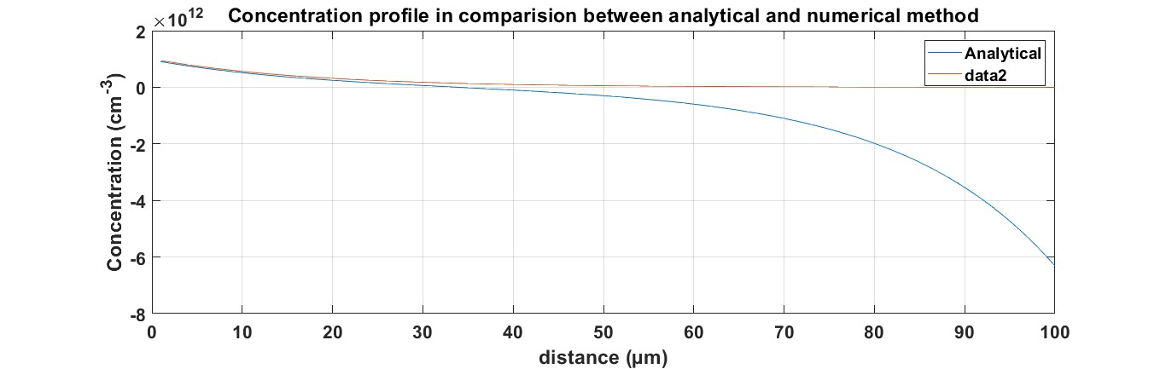

(e) For the configuration in part (a), assume that a particle flux is introduced at x=30

μm at the rate of 1012 cm-2/s. Assume that the particle density at A & B are held

constant at 0 and τ=∞. Find the concentration profile for particles from A to B.

ans

analytical:

y=[];

for i=0:30

x=(7/3)\*10^6\*i;

y=[y x];

end

for i=31:100

x=-(i-100)\*10^6;

y=[y x];

end

i=0:100;

k=i\*10^-4;

plot(k,y);

grid on

xlabel('Distance (µm)')

ylabel('Concentration (cm^-^3)')

title('Concentration profile in Analytical method')

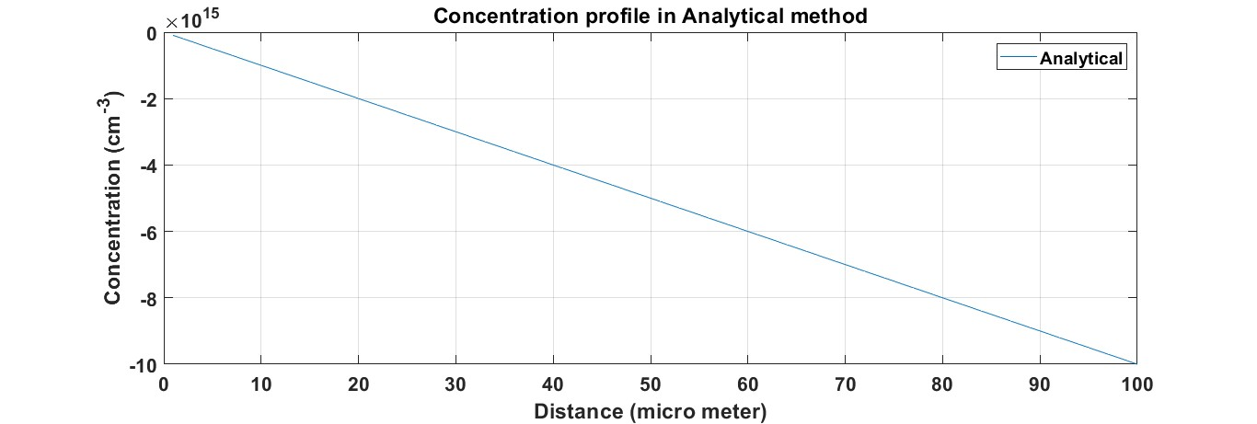

NUMERICAL:

clc;

q=1.6\*(10)^(-19);

a=100\*10^(-4);

h=a/100;

N=100;

D=30;

k=10^12;

C=zeros(1,N);

C(31)=-((h\*k)/D);

C1=C';

for i=1:N-1

M(i,i)=-2;

end

for i=1:N-1

M(i,i+1)=1;

end

for i=1:N-1

M(i+1,i)=1;

end

M(1,1)=1;

M(1,2)=0;

M(N,N)=1;

M(N,N-1)=0;

Cf=M\C1;

plot(Cf);

grid on;

xlabel('Distance (µm)')

ylabel('Concentration (cm^-^3)')

title('Concentration profile in Numerical method');

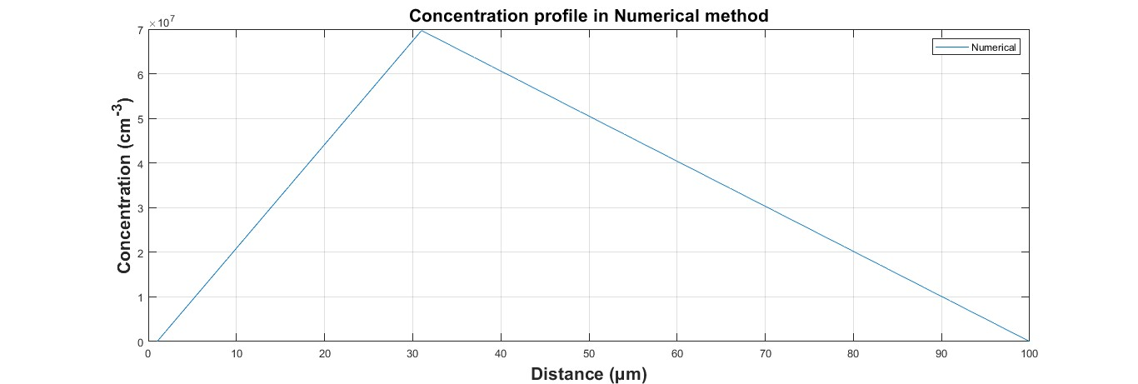

Comparision:

clc;

q=1.6\*(10)^(-19);

a=100\*10^(-4);

h=a/100;

N=101;

D=30;

k=10^12;

C=zeros(1,N);

C(31)=-((h\*k)/D);

C1=C';

for i=1:N-1

M(i,i)=-2;

end

for i=1:N-1

M(i,i+1)=1;

end

for i=1:N-1

M(i+1,i)=1;

end

M(1,1)=1;

M(1,2)=0;

M(N,N)=1;

M(N,N-1)=0;

Cf=M\C1;

y=[];

for i=0:30

x=(7/3)\*10^6\*i;

y=[y x];

end

for i=31:100

x=-(i-100)\*10^6;

y=[y x];

end

i=0:100;

plot(i,y,i,Cf);

grid on;

xlabel('distance (µm)')

ylabel('Concentration (cm^-^3)')

title('Concentration profile in comparision between analytical and numerical method')

